Wiring for the 2x4 connector on the miniature 2315 cartridge depends upon the orientation of the smaller PCB with the microSD card that sits inside the bigger cartridge you designed.

As I designed the small mini cartridge assembly, the microSD card socket sits underneath the board thus defining the pins on the header viewed from the rear as:
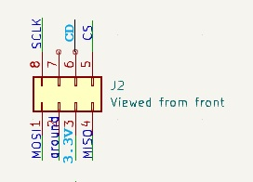

The new cartridge you designed is superb and the decision to mount my smaller PCB with the top of my PCB facing downward is the best visual choice. It does rotate the connector thus the wiring for a socket that your cartridges plug into is:
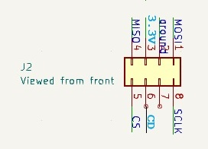

You would not normally care about the wiring because the ribbon cable can be turned to match either orientation. However, if we do find a teeny switch to use as the drive power switch, it would have to be wired in series with the CD wire.

The 10K resistor on my PCB is a pullup resistor for the CD signal, which has to be factored into the connection of a switch. When a card is inserted, the CD pin is shorted to ground.

The teeny switch thus has to have its own pullup resistor on the N/C contact, perhaps 15K. The armature of the teeny switch runs to the pin on the ribbon cable that continues into the main box of my project. The N/O contact of the switch is connected to the header pin for your cartridge that comes from the micro SD card holder.

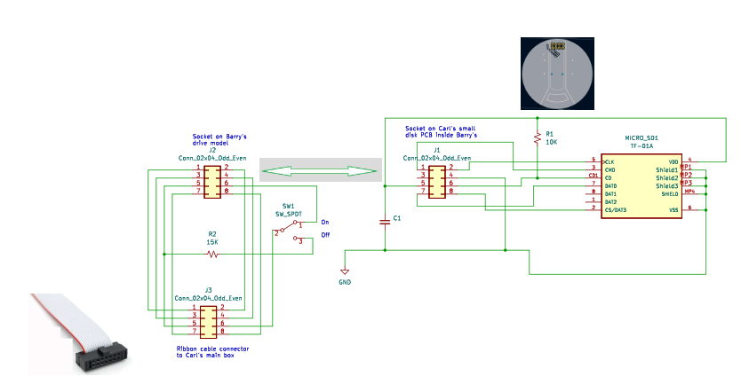

Schematic of the switch and connections between Carl’s mini cartridge header pins, the socket on Barry’s enclosure, the switch and the header into which the ribbon cable plugs coming from the main unit of the virtual disk project.

When the switch is in the down (N/C) position, my circuitry sees a logic high indicating no SD card is present. When the switch is flipped up, it connects to the CD line from the cartridge, either logic high if there is no Micro SD card present or low if the card is there.

This produces the correct behavior. The user inserts a cartridge into the holder, flips up the switch, and then requests my unit to load the contents by turning a switch on my box to the Load position.

A switch that would work in this situation is the C&K ET01M3D1SAPE switch. It has a black plastic toggle handle that is 2.54mm diameter and extends up through a slot a distance of 6.1 mm. The unthreaded bushing is too wide to fit well in the model, so the switch would need to be held underneath with just the toggle handle sticking up. It is a surface mount part fitting on the edge of a tiny PCB with the toggle in the same plane as the board.



